RECOMMENDATIONS FOR THE PARENTS OF A CHILD
WITH SPINAL DYSRAPHIA

Lucy Gooding Pediatric Neurosurgery Center
University of Florida HSC Jacksonville
and
Wolfson Children's Hospital
Jacksonville, Florida
U.S.A.

www.childneurosurgery.com

Sponsored in part by:

The Foundation for Pediatric and Laser Neurosurgery, Inc.

www.fpln.net
TABLE OF CONTENTS

PREFACE……………………………………………………………………………………3

INTRODUCTION……………………………………………………………………………3-4

Development of the Nervous System………………………………………….4-5

Spinal Dysraphia: What is it?…………………………………………………….. 5-6

Classical Clinical Presentation
Orthopedic Syndrome…………………………………………………………………….6
Urological Syndrome……………………………………………………………………..6
Dermatological Syndrome………………………………………………………………..6

Body Systems Affected and Associated Problems
The Musculoskeletal System (Muscles and Bones)………………………………………6-7
The Urinary System………………………………………………………………………7-8
The Digestive System…………………………………………………………………….8-9

treatment: benefits, risks and complications……………………………10

THE IMPORTANCE OF DIET
Nutritional Requirements…………………………………………………………………10
Avoiding Obesity…………………………………………………………………………10

HUMAN SEXUALITY...…………………………………………………………………….10-11

PREVENTION
Amniocentesis………….…………………………………………………………………11
Ultrasonography..…………………………………………………………………………11-12

SUMMARY…………………………………………………………………………………..12

PREFACE

You may have just learned that your child has a spinal problem called spinal dysraphia, tethered cord syndrome or the syndrome of spina bifida occulta. Not only is this medical jargon hard to pronounce, but also the effects of the anomaly sounds quite frightening. We do not expect you to remember all that has been previously relayed to you, but this has the object of aiding you and providing further information.

It is most important for you to understand there is nothing you could have done to prevent this condition and that it is not the fault of any parent. It is also very important that you are fully aware of how this occurred and what we can all do as parents and as a medical team. This booklet has been made to answer many of your questions. Our objective is to address the problems as well as the necessary steps that will be taken to ensure your child’s future strengths and capabilities. Please do not hesitate to contact us, or any of the professionals caring for your child. We are interested in answering your questions, hearing your concerns, and providing support in any way you find helpful.

INTRODUCTION

Birth defects in general are more common than one might imagine, with 5 out of every 100 children born with a significant abnormality. Considering the complex events leading to the development of a human child, 5% is certainly a low figure.
Congenital spinal anomalies most commonly occur from failure of closure of the neural tube and adjacent skin, muscle and bone structures; these are embraced by the term spinal dysraphia, spina bifida occulta, tethered cord, and they are all synonyms. These anomalies are distantly, but definitely, related to myelomeningocele or spina bifida cystica.

The primary care personnel may be presented with a subtle or gross change in the size of the legs, or with an infant with repeated attacks of urinary tract infection. These may be the sole indicators of an underlying progressive neurological disease that will cause further silent damage if the appropriate diagnosis and treatments are not made.
The orthopedic personnel may see an infant or a child with a deformity of the legs and determine the need for corrective surgery. This will not be rewarding, as the deformity will recur if spinal dysraphia is the cause of the deformity, because of the interruption of the nerve supply to one or both legs. Appropriate treatment should be directed at the spinal disorder and then the legs.
The urologist may see a child who fails to control bowel and bladder function, or after having acquired control proceeds to lose that control. Though the usual urological tests must be performed to determine the state of the kidney function and the presence or absence of structural anomalies of the urology system, the most appropriate studies are directed towards the spine and nerve problems.

A lot of research is presently ongoing to determine the cause of these spinal defects, but only theories have evolved. The best explanation to date is there is a combination of factors involved: some environmental and some genetics. What results is an abnormal sequence of steps in the development of the spinal cord during the first month of pregnancy, even before the mother is aware that she is pregnant. We want to emphasize that neither parent is to blame. Factors beyond their control, which even today baffle medical scientists, that have been known historically as a problem, contribute to the formation of the dysraphic state. Special tests will be discussed later that can be performed during future pregnancies to ascertain whether spinal cord malformation could be present.

DEVELOPMENT OF THE NERVOUS SYSTEM

The nervous system consists of the brain and spinal cord (central nervous system, or CNS) and the nerves that extend out from these structures to the muscles, glands and skins (peripheral nervous system). During early pregnancy, the CNS begins as a single sheet of cells called the neural plate, which enlarges to form a little canal (groove) that eventually deepens further until it finally forms into a tube. This tube will then make the brain and spinal cord. (Figure 1)

Figure 1. Development of the spinal cord during the first few weeks of life.
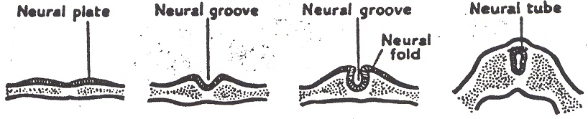
(a) Neural plate  stage | (b) Early neural  groove stage | (c) Late neural  groove stage | (d) Early neural  tube stage

Following this, supportive and protective tissues develop to enclose the spine and brain. These are thin membranes called the meninges. Finally, bone covers all of this system. Surrounding the spinal cord is the backbone or spine, which consists of 33 hollow, rounded sets of bone called vertebrae. The skull bone surrounds the brain.

In Figure 2 the backbone is demonstrated. Since it is extensive, it has been divided into 5 areas with each region having a name. Spinal dysraphia occurs most commonly in the lower end, in the lumbar and sacral regions. Within the bony spine are the spinal cord and nerves.

The nervous system works much like a telephone system and the brain could be thought of as the central portion of the system. The main cable from this central portion is the spinal cord, and the individual spine lines are the peripheral nerves that extend to the arms, legs, bladder and intestine. They enter and leave the spine through spaces between the vertebrae.

There are two types of peripheral nerves: incoming and outgoing. The outgoing system is commonly referred to as the motor system, and it ends in the muscle and various bodily organs. When these nerves are properly connected they allow the person to move and do such things as to eliminate waste from the body, from the intestine and from the bladder. The incoming system is the sensory systems. These nerves end in the skin to detect the different sensations such as heat and cold, and also to the organs for the perceptions of vision, hearing and smelling. When we see, hear, smell or touch something, the nerves then relay the information to the brain. When the bladder or bowel needs emptying, these messages are also sent to the brain by the sensory nerves. In turn, the motor system responds by sending signals from the brain to the muscles or these structures to react in some way or move the various parts of the body. As a rule, the nerves that control the bladder, bowel and sexual function are located at the lowermost end of the spine (sacral region). The next to leave the spinal cord going upwards are the ones to the feet, ankles, calves, and knees, and progressively up the body.

Figure 2. The spine.
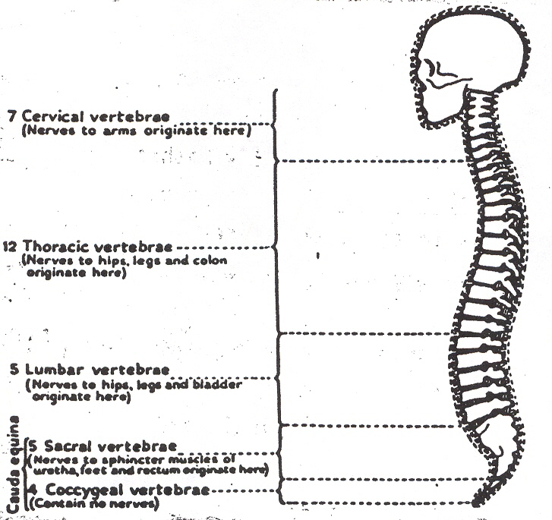

Spinal Dysraphia: What is it?

Spinal dysraphia is a term commonly employed to differentiate a group of disorders of the spine that are less obvious to everybody than the myelomeningocele or spina bifida cystica, in which the baby is born with an open spine with defective skin or varying degrees of deformity of that region of significance. It is a series of developmental anomalies of the back of the embryo involving the three layers that form the fetus called the ectoderm, mesoderm, and the endoderm at times. It is commonly used to describe the findings of a slow and progressive condition that is quite difficult to diagnose, involving one or both legs, the bowel and bladder, or a combination of all of these.

Spinal dysraphia occurs due to a loss of nerve function in a progressive fashion. This can be the cause of urinary symptoms such as unexplained infections or changes in the self-restraint pattern that the child may have acquired. On occasion there may be a combination of both leg and bladder problems. The importance is that early detection and prompt treatment must be instituted for this disease in order to prevent its crippling effects as the child develops. The mechanisms may have occurred by a number of ways: small masses may be growing inside the spine that can put pressure on the spinal cord or the nerves and cause mechanical damage to these structures, with a consequent loss of nerve function. This has been given the name of the compressive mechanism.
Another explanation for the disease that is less easily explained and felt to be due to a limitation of the normal upward movement inside the bony canal of the bottom of the spinal cord and lower nerve roots. If an underlying problem does not allow fro this upward migration to occur, damage to these structures will follow because of the pulling apart of these structures (tethering effect). This will also lead to damage to the nerve supply because of its interruption, involving similarly the legs, bowel and bladder reflex mechanisms in varying degrees.

CLASSICAL CLINICAL PRESENTATION

The usual form of the child manifesting this disease of spinal dysraphia tends to vary. The most common three forms of presentation have been defined as follows:

Orthopedic Syndrome

The orthopedic syndrome is characterized by difference in the size of the legs, atrophy (wasting), a smaller foot or smaller limb portion, which may manifest at birth. Commonly it starts in one leg and with time goes on to the other. At times, these findings are subtle and then become more evident as the child grows.

Urological Syndrome

The urological syndrome may present with findings that are varied and initially the infant may have repeated, unexplained urinary tract infections that most likely develop secondary to poor nerve function of the nerves that give either the motor or the sensory innervation, or both, to the bladder wall and sphincters. In other cases the child may have difficulty in emptying and controlling bladder function.

It is not uncommon for these two manifestations to overlap as the disease progresses, and then the patient has obvious orthopedic and urological anomalies.

Dermatological Syndrome

The dermatological syndrome is another form of spinal dysraphia in which there are skin spinal anomalies in the middle of the back, usually again in the lower back, initially with or without other symptoms of the disease. From the review of the medical literature it becomes apparent that the most frequent presenting initial sign is either a skin anomaly in the lower region of the spine or buttocks, or an orthopedic presentation in one or both legs.

BODY SYSTEMS AFFECTED AND ASSOCIATED PROBLEMS

The Musculoskeletal System (Muscles and Bones)

You may have already spoken with an orthopedic surgeon caring for your child. Orthopedics is the medical specialty that deals with the bones, joints, ligaments and muscles of the body. One of the main problems in these diseases may be that the nerves that control the muscles of the lower half of the body have been damaged to some extent.
As a general rule, the lower the dysraphic condition the more function of muscles in the legs. The upper lumbar nerves serve the hips and thighs; the lower lumbar nerves move the knees and the fronts of the lower legs. The sacral nerves serve the soles of the feet and calves. If the nerve supply to a muscle leaves the spinal cord above the level of the lesion, those muscles controlled by those nerves may function normally. If, however, the nerve supply comes up below the level of the problem, there are several possibilities:

- If the lesion is severe, the nerve transmits no impulses, the muscle does not function and the joint it passes over may be next to floppy or limp. This is termed a flaccid paralysis and it occurs in the severe cases or if the disease has been going on for a long time before it is detected.
- A few of the many filaments of the nerve may transmit the impulses, the muscle functions, but it will be weak (there is some degree of control by the brain).
- There may also be muscle tightness or stiffness. This occurs when the spinal cord at or below the dysraphia is functioning without the control of the brain (functions only because of reflex activity). You may also hear this problem called spastic paralysis.

Dislocations and deformities may occur. Commonly the muscle on one side of the joint may pull strongly while the other side pulls very weakly or not at all. Since joints are held in position by the muscles that surround them, they may come out of position easily. In children with spinal dysraphia, the joints may be abnormal in their shape. Since the muscles develop to a great extent before the baby is born, the deformities are at times assuming the position the child had in the womb.

Quite soon after birth the orthopedic surgeon will want to splint or cast the lower extremity if a deformity is severe enough, because it may continue to go onto a contractures or permanent deformity. As the parent you have an important responsibility in trying to prevent these contractures and further deformities since they can interfere with bracing and other forms of treatment that may be given to increase the mobility of the child, as he grows older. One way to do this is by performing daily range of motion exercises on the baby’s legs. By moving the feet, knees and hips up and down, and side to side, the muscles and joints will stay somewhat flexible. The physical therapist will be the person that will instruct you on the proper method.

Naturally the primary goal of the treatment by the orthopedist is to have all children stand and walk. Continuous follow-up may be required according to the degree of nerve interruption. At times surgical procedures for tendon releases and repositioning may be required to maintain a proper muscle balance in the leg. At times, the spine will have curvatures that need to be corrected or supported.

We wish to stress that no two children with spinal dysraphia are alike. Do not listen to people who often make incorrect predictions about your child. The combination of treatments, with a combination of underlying pathology determines your child’s outcome.

The Urinary System

The center for control of the bladder is in the sacral region of the spine. When the defect is located in this area, components of the urinary system are usually not working properly in varying degrees. These include the bladder (a muscle reservoir that stores the urine formed by the kidneys), and the two sets of sphincters (the muscles that control the outflow of urine from the bladder). (Figure 3)

When the system does not work properly, the child will have difficulty or may even find it impossible to urinate only when convenient, a condition we call incontinence. There are two main types of incontinence. If the sphincters are always relaxed because the nerves never tell them to tighten, the urine runs out of the bladder all the time. This type of bladder can never store urine, so it develops as a small bladder with no capacity. Often, the nerve damage is such that the sphincter is working too much and it cannot open. As the bladder becomes full it distends too much, dribbling of the urine can occur as the dam overflows and it also begins to back up into the tubes joining the kidneys and bladder (ureters). This “reflux” eventually causes the kidneys to be subjected to much high backpressure than is healthy for them and damage can ensue.

Figure 3. The normal urinary system.
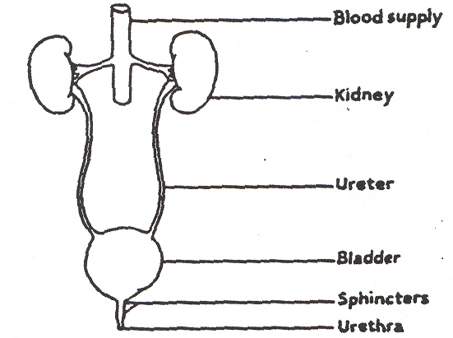

Closely related to the reflux and the lack of adequate emptying is urinary tract infection (UTI). Because of urine stagnation, infection can easily take hold and give a bladder infection (cystitis) or a kidney infection (pyelonephritis). This is closely manifested by fever, bellyache, pain and/or burning during urination, foul-smelling urine, or blood in the urine. Permanent kidney damage can be life threatening; therefore, children with dysraphia must be watched very carefully by the urologist from birth.

One test frequently ordered by the physician is the intravenous pyelogram (ICP), which assesses kidney function. This is an x-ray that shows the size, shape and location, as well as emptying capacity of the kidneys and ureter up to the bladder. Urodynamic testing is the basic way of finding out how well the child can control the urine and emptying of the bladder, and which nerves and muscles are working. It is usually performed after a child has been sedated, and it is a test that ascertains the strength of the sphincters and their ability to open and shut, the volume capacity of the bladder, the bladder’s ability to relax and store the urine, the ability of the bladder to raise its pressure and empty urine, and finally, the ability of the bladder and sphincters to work as a team. The information obtained from this study is used to plan the child’s management, usually in reference to teaching how best to control the passage of urine. Obviously this becomes extremely important at two to three years of age, when toilet training is desirable. Your pediatric urologist will provide further information and guidance.

The Digestive System

In persons with spinal dysraphia, there may be a problem of the voluntary control of the emptying of the intestines. The amount of control depends on whether the spinal cord lesion, or the nerve root lesion, is severe enough to cause that kind of damage. Generally, if the dysraphia is above the sacral area, the lower bowel and sphincter muscle that closes the anus (opening to the outside of the body) are unable to function with normal strength. (Figure 4)

Constipation may be a problem, and it can lead to impaction or blockage of the bowel. Loose stool may then leak around the hard stool, resulting in unexpected bowel movements. Chronic constipation may cause other problems if it is severe enough. For instance, it may affect the function of the urinary system by pressing on the bladder and ureters, which may interfere with proper emptying of the urinary tract. The pediatrician and urologist usually coordinate an effective bowel management program that involves diet modification, careful planning, and at times, medications. Patience is required during the phases of balancing these different aspects, when timing must be adjusted or when the needs of the child change.

Figure 4. The Digestive System
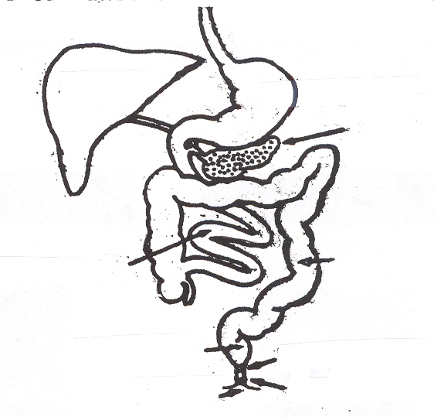

LARGE INTESTINE

PANCREAS

STOMACH

INTERNAL SPHINCTER

EXTERNAL SPHINCTER

RECTUM

ANUS

SMALL INTESTINE

LIVER

It is always important that bowel care is made to be not distasteful or frightening, but rather, the management should be emphasized as pleasantly as possible. The child should be encouraged to become actively involved in the routine and be as independent as possible, even when he is young. Although bowel and bladder management can constitute a difficult and long-term problem, the rewards are extremely important for a socially well-adjusted child.

TREATMENT: BENEFITS, RISKS AND COMPLICATIONS

Therapy has been recommended to prevent the crippling progressive effects of spinal dysraphia. If not treated early in a child’s life, the nerve cells and axons (nerve fibers) are sufficiently damaged by the time treatment is done and they will not recuperate. The object of an operation is to remove the underlying pathology whenever possible. In those patients in which there is a tethering effect, sectioning and releasing of these structures will release the nerves and spinal cord, and allow them to function better. When compression of the lower end of the spinal cord occurs, then decompression of the spine and total or subtotal removal of the mass must be performed to stop deterioration.

Modern neurosurgery has permitted operations to be performed with care and less risk of complications. The application of the operating microscope, microbipolar cautery, microinstrumentation and laser neurosurgery allows for meticulous microdissection of the nerve roots and lower end of the spine. Structures involved in the disease process such as fatty tumors, can be removed, if not completely, with care not to damage the elements and other related structures. The risk of recurrence is not only minimized by this technique, but postoperative worsening with a technique of intraoperative monitoring has been minimized. The application of the rectal sphincter electromyogram and urodynamic equipment allows the neurosurgeon to detect neural structures, which may be hidden within the deformity. Thus, though there is a risk to any operative intervention, the modern techniques have minimized complications and have assured the best possible quality of outcome and prevention of further neurological damage.

THE IMPORTANCE OF DIET

Nutritional Requirements

Your child should be fed three balanced meals daily. Vitamins play an especially important role in planning optimal care for children with multiple body system problems. For example, to keep the urinary system functioning well, vitamin C is of great importance. Juices, such as orange and cranberry, as well as green vegetables and fresh fruits are all excellent sources of vitamin C.

Avoiding Obesity

A child’s ability to move is restricted further when he or she is overweight. Also, under these circumstances unnecessary strain is placed on the muscles surrounding the spine. Spinal lipomas may also increase in size when your child gains weight. Therefore, it is very important to avoid obesity.

Your child’s pediatrician is the best person to advise you on the proper weight at which to maintain your child. Usually this is based on height, and not the age of your son or daughter.

Human Sexuality

Sexuality exists throughout life and is composed of many facets: the acknowledgement of sex, the way we feel about ourselves as individuals, our way of life, the way we were treated, the way we react to other people, and personal self-image as a human being, particularly as human beings likely to attract and be loved by others.

One of the primary problems that may be encountered in this area by people with spinal dysraphia involves nerve damage, as with the bowel and bladder, or the nerves to the sex organs, which may result in poor sensation of the genitals. Although the sperm count may be adequate in men with this disorder, they may be unable to develop an erection of the penis or ejaculate with appropriate timing. Several studies have indicated, however, that even with a myelomeningocele, women are usually capable of bearing healthy children vaginally. With today’s technology, there are many available means of aiding the couple that is experiencing difficulty with sexual expression or reproduction. Since aggressive measures for treating spinal defects and related conditions have only been present for the past few years, the present generation is really the first to be confronted with the problems and potential solutions that may be created in relation to this issue.

PREVENTION

Symptomatic spinal dysraphia should be given the same familial concerns and the physician gives myelomeningocele or spina bifida cystica patients in reference to recurrence. Studies have shown familial recurrence in patients with documented clinical spinal dysraphia. The findings of these studies were statistically significant. Families with children with spinal dysraphia should therefore receive appropriate genetic counseling.

Amniocentesis

Amniocentesis is a prenatal diagnostic test that involves drawing a small amount of fluid from the uterus via needle insertion through the abdomen by the obstetrician. This is a painless procedure and involves minimal risk to the baby. It is usually performed between the 10th and 14th weeks of pregnancy. The amniotic fluid that surrounds and protects the baby is tested for a specific protein called alpha-fetoprotein. This substance is normally found in the developing nervous system. If the skin is open over the spinal cord and nerves, then this substance gets into the fluid and the myelomeningocele or spina bifida cystica can then be documented. If the skin is closed, however, this test will be negative. Therefore, this is a good test for the myelomeningocele and related problems, but it is not a test that is good for spinal dysraphia. Accordingly, since there can be a high risk of spina bifida cystica in families with spinal dysraphia, this test has a great value. If the test is positive, a decision whether or not to carry out the pregnancy can be made by the parents.

Ultrasonography

Another prenatal test that is more useful in dysraphia, although not 100% reliable, is the ultrasound. Using a radar-like device that is harmless to both the mother and fetus, a photographic tracing of sound waves being bounced off the back of the baby is obtained. The ultrasonographer is able to look directly at the fetus in the womb and can tell if there is any gross defect in the spine. Some obstetricians are now choosing to perform a routine ultrasound in all pregnant women who are, at least in their pregnancy, considered for some reason to be complicated.
Though the ultrasound does not always reveal spinal dysraphia, severe spinal anomaly will be seen using this method.

SUMMARY

Hopefully the information provided in this handout has helped you to understand what the physician and medical team can do to minimize the consequences of your child’s condition. Our aim has also been to make your efforts less strenuous and more effective, as well as to help your child achieve the satisfaction that every parent hopes for in the future.

HEJ/js
Reviewed/Revised 10/10/2007

