RECOMMENDATIONS FOR THE PARENTS OF A CHILD
WITH CRANIOFACIAL DYSOSTOSIS

Lucy Gooding Pediatric Neurosurgery Center
University of Florida HSC Jacksonville
and
Wolfson Children's Hospital
Jacksonville, Florida
U.S.A.

www.childneurosurgery.com

Sponsored in part by:

The Foundation for Pediatric and Laser Neurosurgery, Inc.

www.fpln.org
PREFACE

If your child has been diagnosed as having a deformity of the head and face, which will require surgical correction, then a significant amount of stress has been placed on you over the cause of the problem, the treatment, and what will happen to your child and the future of your family.
The purpose of this handout is to assist you with the understanding of the problem, the treatment, and the end result, by looking at the various forms of craniofacial dysostosis, the evaluation, diagnostic procedures, and principles of correcting the disorder. The most common questions raised by parents have also been addressed.

INTRODUCTION

The term “craniosynostosis” refers to the bones of the top of the head, the “cranium.” In this disease, the bones of the top of the head are involved. (Figure 1)

Figure 1. NORMAL HEAD: The head is formed by the calvarium (cranium) and the face.
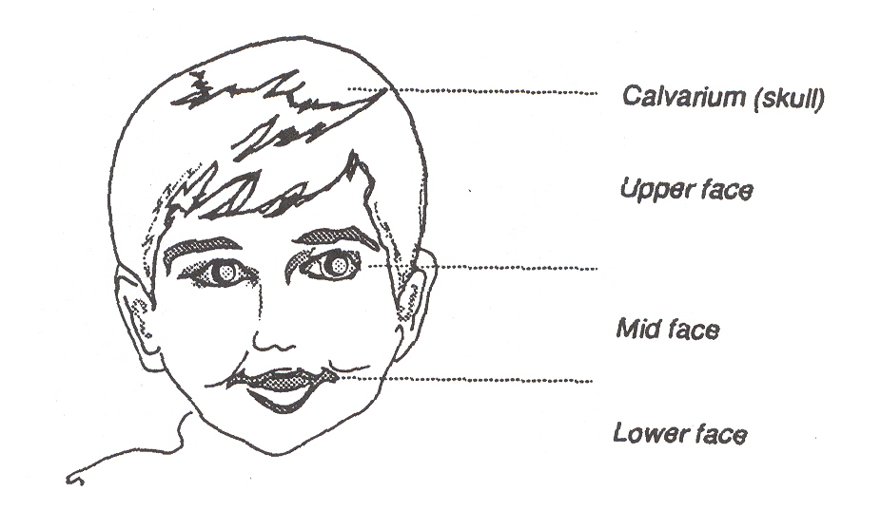

Accompanying this problem of the bones of the calvarium, there is a deformity of the face (upper and lower face), due to a premature closure of the sutures of the bones of the face. The facial structures have then not been allowed to move to their normal position.

Because of the involvement of the covering of the brain, the potential for limitation of the brain growth, the possibility of associated hydrocephalus and the age of your child, your primary care physician has asked you to see specialists for definitive diagnosis and treatment and a neurosurgeon who specializes in children.

Figure 2. Illustration of the cranium bones
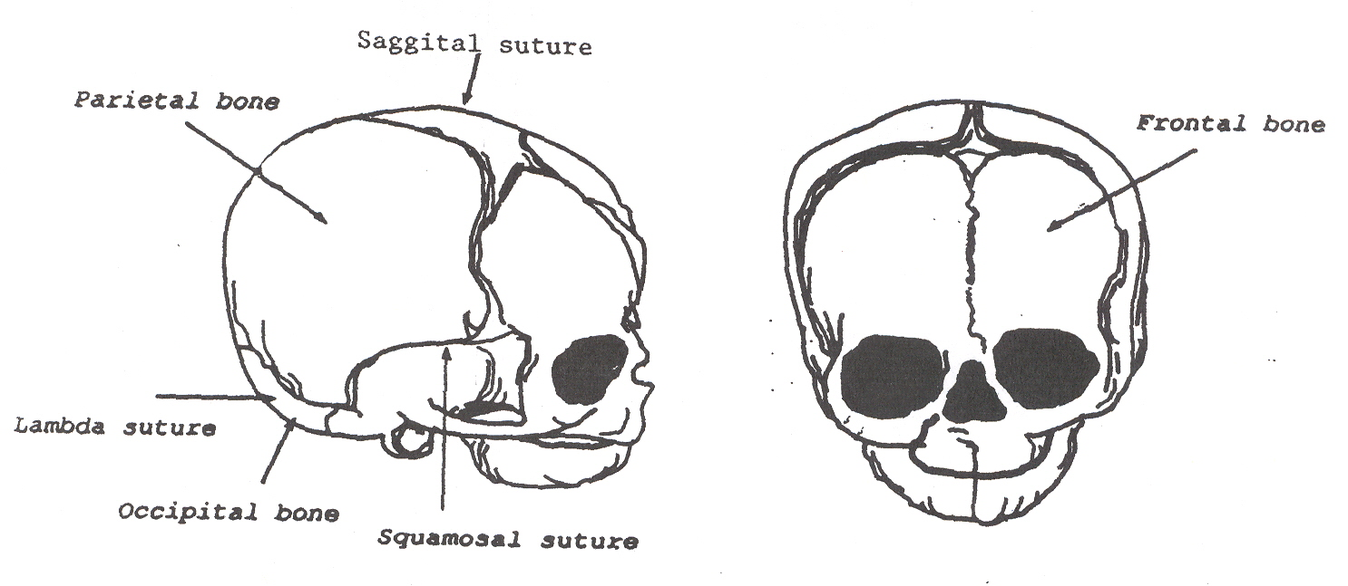

NORMAL SKULL ANATOMY

Five sets of bone make up the cranium:

Frontal bone (one)
Temporal bones
Parietal bones
Occipital bone (one)

Joining these bone plates together are points of union called “sutures.” Each one carries a different name. For instance, the connection between the single frontal bone and the adjacent parietal bone is called the coronal suture.

Craniosynostosis results when one or more of these sutures close (“ossify” or “synostose”) too early during the infant’s development. This creates is a limitation in brain growth, as well as a consequent deformity of the head due to the restricted growth in that area. The majority of craniosynostosis is diagnosed by the examination of the child due to the typical deformity that the closure of the involved suture(s) creates.

NORMAL ANATOMY OF THE FACE

The facial appearance of your child is determined by the underlying bone structure. The “cheek bones” are the bones that account for the particular formation of the midface. The bone is called the zygoma. The base of the nose is caused by an indented bone plate part of the frontal bone. The rest of the structure of the nose is determined by a combination of small bones (nasal bones) and cartilage. The superior aspect of the face over the orbits is formed by the frontal bones and to the side by the zygoma. The center of the face, the midface, is formed by the union of several bones: the maxilla, ethmoid, frontal and to the side by the zygoma. Behind these, at the base, the sphenoidal bone connects to them. These bones come together at their corresponding sutures. In craniofacial dysostosis there is, like in craniosynostosis, a premature closure of these sutures.

DEVELOPMENT OF THE BRAIN

Inside the womb, development of the brain and spinal cord (central nervous system) of the fetus takes place within the first four weeks after conception. Formation of the craniofacial structures around the brain is a very complicated and poorly understood process. Normally a baby is born with sutures that allow the bones to stay separate and permit ready growth of the brain by allowing the bones to spread apart as the brain increases in size, and therefore adapt the calvarium to the needs of the brain. This accounts for the rapid increase in the head circumference in the first few months of life.

The principal sutures in the infant skull are the sagittal, coronal and lamdoid sutures (see Figure 2). There are two major soft areas, the anterior and posterior fontanelles. These “soft” areas are very important in early infancy for the rapid growth of the cranium. The brain growth is extremely rapid in the first two years of life so that 75% of the total growth of the brain is completed by 18 months of age. Normally in doing this the brain will have tripled in weight and size during this period.

The skull grows in a direction perpendicular to the line of the suture, and normal closure of the suture(s) occurs in a regular and predictable order. Although there are normally wide variations in the age at which the sutures are “hardened” (ossified), the usual pattern is as follows:

Three (3) months of age: the posterior fontanelle closes
Six (6) months of age: the basic union (but not closure of) sutures
Twenty (20) months of age: the anterior fontanelle is closed
Adolescence: solidly formed skull

CRANIOSYNOSTOSIS – CRANIOFACIAL DYSOSTOSIS

Craniosynostosis is the term employed to define premature closure of sutures. At times it is used interchangeably with the term “craniostenosis;” however, for some this term means a premature closure of all sutures of the calvarium.

From what has been said previously on the normal pattern of brain development, it is now easier to imagine that fusion of these sutures in the first months of life can restrict brain growth, which could lead to varying forms of brain damage. This will be determined by how many sutures are involved, how long the closure has been going on for, and the success or failure of the other sutures to compensate the expansion.
In craniofacial dysostosis, there is craniosynostosis and premature closure of the sutures of the face as part of the same deformity. Consequently, there is involvement of the skull as well as the upper and midface. By some, the premature closure of the sutures of the midface is called “faciostenosis.” The bones of the face have not moved forward and retained the normal formation of the midface, giving a “sunken” appearance to the same, relative to the position of the forehead and the jaw (mandibular bone). This sunken midface is called “facial retrusion.”

Craniofacial dysostosis may represent a single primary defect in an otherwise normal child, or it may be on feature of a syndrome involving other malformations. This may then be of subsequent genetical importance.

CLINICAL FORMS OF CRANIOFACIAL SYSOSTOSIS

There are many forms of craniofacial dysostosis, some well described and some poorly understood and incompletely listed in the medical literature. Most of these have variations not only in the degree of craniosynostosis, but also in the magnitude of faciostenosis, involvement of orbits, etc. However, several have together with these deformities of other parts of the body, particularly the hands and feet. The fingers and toes may be fused together (syndactily), or may be different in length and size to the normal. The constellation of these findings allows the physician to prognose how that particular child will develop in some cases, and it will permit the identification of the genetical importance of this disease to that family and child.

Common features, with variations are as follows:

- Deformity of the calvarium (craniosynostosis). A deformity in the form of a high and tall skull is common (oxycephaly or turricephaly), caused by a premature closure of various sutures of the calvarium, primarily a bicoronal and bilambdoidal synostosis. (Figure 3)
- A “sunken” midface (facial retrusion).
- A flat or underdeveloped nose.
- Increased distance between the eyes (hypertelorism).
- Prominent bulge to the eyeballs (exhorbitism). This is due to the very shallow formation of the orbits due to the prematurely closed sutures.
- Varying degrees of alignment of the teeth due to the lack of growth of the maxilla (where the upper teeth are), and the mandible (where the lower teeth are).
Figure 3. Oxycephaly or Turricephaly: Premature closure of all coronal and
lambda sutures, resulting in accelerated upward growth and small head
circumference.
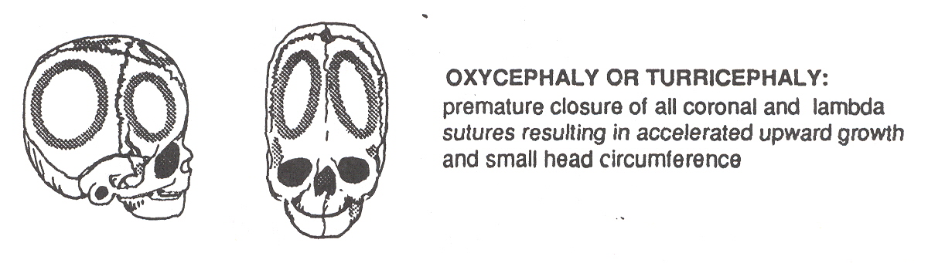

CROUZON SYNDROME

In this form of craniofacial dysostosis, there is premature closure of both coronal sutures primarily, with varying degree of closure of both lambda sutures, and the sagittal may then close too with time. This then leads to a tall calvarium (oxycephaly or turricephaly) as seen in figure 3.

There is, as expected, all the changes previously discussed for the upper and midface regions. The hands and feet are normal. Crouzon syndrome may occur as a sporadic presentation, which is when the family has not had any prior children with this problem, or it may occur in familial form (in families).

APERT’S SYNDROME

This form is more rare than the previous one and it has all the findings described in Crouzon syndrome, but with these added features:

- Fusion of the fingers and toes (syndactily).

- A very high arched palate (that may have a defect in it).

- This form of craniofacial dysostosis may have a higher incidence of mental retardation than in Crouzon syndrome.

- This form may also have a higher incidence of hydrocephalus than in Crouzon syndrome.

SAETHRE-CHOTZEN SYNDROME

This is possibly the most common craniofacial dysostosis but because many of them have “mild” deformities, they are not readily diagnosed. They have the findings described of the Crouzon syndrome but they may not be as severe. The presence of craniosynostosis usually leads to a broad forehead (acrocephaly). They have partial fusion (syndactily) of second and third or third and fourth fingers, broad thumbs, short fingers and deformed fifth fingers. Other members of the family may have these findings when attention is paid to them, but since they have a milder form, they were not recognized as having the syndrome.

PFEIFFERS SYNDROME

This is a very rare form of craniofacial dysostosis that has the cranial characteristics of Crouzon syndrome and is accompanied by broad fingers and a large big toe.

CARPENTER SYNDROME

This is also a very rare form of craniofacial dysostosis that has the cranial findings of craniosynostosis and faciostenosis, and is accompanied by a broad forehead (acrocephaly) and the inner aspect of the eyelids displaced sideways. The hands have very short fingers, partially fused fingers and deformities of toes.

HYDROCEPHALUS

Hydrocephalus may be present in craniofacial dysostosis. The term “hydrocephalus” (from the Greek term of “water in the brain”) is employed to describe an abnormal accumulation of the cerebrospinal fluid that circulates in the inside and outside of the brain. In these children the normal production of the fluid is taking place, but due to the malformation of the cranium it cannot leave the spaces to go back to the bloodstream (in the veins). This progressive buildup of fluid creates pressure from within the brain and makes the normally located cavities inside the brain enlarge. If untreated, hydrocephalus by itself causes brain damage as the brain becomes thinner and is placed under progressively higher tension. When diagnosed it will be treated by the pediatric neurosurgeon with a shunt procedure or a third ventriculostomy. If you should need further information because your child has hydrocephalus, we refer you to the Hydrocephalus Handout for parents.

DIAGNOSIS

The more severe forms of craniosynostosis and craniofacial dysostosis are diagnosed readily at birth, whereas they might be mild enough not to cause suspicion on examination. The diagnosis is made in most of the babies just by examining the child for the signs that were previously discussed.

PLAIN RADIOGRAPHS (X-RAYS)

Plain radiographs of the child’s head (skull x-rays) will reveal bone bridging the defect of the suture, which normally is not present. The accompanying deformity of the cranium and face will allow the physician to see the disproportion of these structures and diagnose the craniofacial dysostosis radiologically.

COMPUTED TOMOGRAPHY (CT SCAN) OR MAGNETIC RESONANCE IMAGING (MRI)

This sophisticated equipment allows for a noninvasive way of looking at the inside of your child’s head by employing computers connected to x-rays (CT scans) or to a giant magnet that creates magnetic fields (MRI scans). With this technique your physician will be able to see if there is hydrocephalus because the enlargement of the normal cavities that contain the cerebrospinal fluid is readily seen. If this is present, the pediatric neurosurgeon will treat this with a shunt procedure or a third ventriculostomy.
The CT and MRI also allow for the physician to see if there are any other structural changes in the brain of your child. However, it is most important to realize that even though the brain can clearly be seen, your physician cannot tell how well it is working. In other words it cannot tell if your child will be bright or have mental retardation.

The CT permits the physician to see the structure and abnormality of the bones of the skull and face. At times, this information is employed to create a three-dimensional (3D) reconstruction of the deformity. In the complex cases this permits the Craniofacial Team a better planning for the surgical correction of the malformation.

THE GENETICIST/DYSMORPHOLOGIST, YOUR CHILD, AND YOUR FAMILY

The geneticist/dysmorphologist is a pediatric specialist in birth defects. This physician will examine your child and evaluate your family history in an attempt to determine the cause of the craniofacial malformation. Not only is this important for your child, but then according to the type of syndrome, this physician will inform you of the potential risk factors of having other children with craniofacial deformities. The risk in some cases of having another child with this may be as high as 50% or as low as zero.

To that end the dysmorphologist may order some specific tests, such as chromosomal analysis if felt needed, to confirm or deny some malformation syndrome of genetical importance.

All of the above is also important for your better understanding of your child’s problem and may help in the anxiety you are going through.

THE CRANIOFACIAL TEAM AND WHAT IT CAN DO FOR YOUR CHILD

As you may have seen during the reading of the handout, we have already referred to many specialists that may be involved to help your child. Your primary doctor will always be that, the primary one in day-to-day care of your child. The others, the specialists are consulting in the care of your child for the specific problem of the craniofacial deformity and will assist your doctor in that aspect of your child’s care.

The objective of the craniofacial team is to allow for your child to be evaluated by all the needed specialists and the short term and long term treatment planning better coordinated. Once the team has not only confirmed the diagnosis and instituted a long term care plan, the priorities of care of each specialty is identified and given the necessary coordinated effort to maximize them.

In charge of that coordination, and bridging between the specialists and the healthcare agencies, is the geneticist/dysmorphologist. This physician presides the conferences that are being held with all the specialists, takes the necessary information from them, and discusses with them and the healthcare agencies the treatment plan and the priorities.

TEAM MEMBERS

Geneticist/Dysmorphologist

This physician is the Craniofacial Team Clinic Coordinator. His/her role in the team was discussed in the previous paragraphs.

Plastic Surgery/Maxillofacial Surgery

The plastic/maxillofacial surgery team is the crucial part of the team. They deal with the reconstruction of the face and correction of the deformities of the same. Decisions as to when to correct the facial anomalies, timing and staging of these operations/procedures are made by these members of the team. The cosmetic correction will be of great importance for you as well, and they will discuss these various aspects with you, your primary care doctor and the other team members.

Pediatric Neurosurgery

The role of pediatric neurosurgery is to support and maximize the structural growth of your child’s head and brain. This will be performed by correcting as early as possible the craniosynostosis, and if indicated, treating the hydrocephalus. These are the critical priorities in the early months of your child’s life. The various aspects of this care have been discussed in the previous section. The pediatric neurosurgeon will assist the plastic surgeons whenever craniofacial surgery is performed if the surgery for the face involves the cranial component, and will assist in the postoperative management.

Otolaryngologist

This physician specializes in the problems of the ears, nose and throat, basically the upper airways of your child. He is an important team member because commonly, the restricted formation of the midface also restricts the airways. These children have very commonly repeated ear infections (“otitis”), which if not followed closely and promptly treated, may create problems in the hearing mechanisms inside the ear. This physician may also order special tests to better treat your child. He/she will then not only inform the team members of the findings, but will communicate with your primary care physician if any special care or medications are needed.

Ophthalmologist

These physicians specialize in the care of the eyes and vision. They are important team members because of various possible deformities that may cause problems with vision. In those children with a wide distance between the orbits (hypertelorism), the small muscles inside the orbits that move the eyeballs to be able to focus vision may not be able to work correctly because of the deformity. This creates difficulty for vision by limiting the ability of both eyes to see an object in the same point of focus (conjugate vision). With time, nature responds with one eye being used to see more than the other. As the other eye is used less, it sees less and less, and may finally become blind. The ophthalmologist will be testing vision and eye muscle movement, and informing the team members and your primary care physician of any problems and treatment(s) needed.

Orthodontist

The orthodontist specializes in correcting those deformities of the mandible and jaw so that your child’s upper and lower teeth match (oral occlusion). This may be performed with braces and various orthodontic devices according to the age of your child and the underlying deformity.

The orthodontist relies for this on the examination of the mouth and the x-rays, specially the cephalometric x-rays that were previously discussed. The correction of occlusion and underlying deformities often bring into play various team members for the correct timing for this crucial work, that is strongly related not only to the deformity, but to the age and child’s development. The important team members are the plastic surgeon, the oral surgeon if needed, and your child’s dentist.

Oral Surgeon

The doctor in oral surgery is specially trained for those situations where surgery for the jaw, mandible and surrounding facial structures is needed. They will work with the plastic surgeon and your child’s dentist to help plan correct the deformities in the area and help when necessary for a better occlusion of your child’s bite.

Speech Pathologist

This person is specially trained to detect the possible problems that your child may have in pronouncing words (speech). The diagnosis of an underlying problem is treated with speech therapy, or if necessary, with orthodontics and related procedures that may improve your child’s articulation.

Audiologist

This person is specially trained to test your child’s ability to hear. If hearing difficulties (deficits) are present, the type is identified and the information is given to the otolaryngologist and speech pathologist for treatment. If hearing aids become necessary, the audiologist helps fit your child with these, according to the otolaryngologist’s instructions.

Psychologist

The doctor in psychology will be available to identify your child’s and the family’s psychological needs, and aid in communicating with your child’s school as needed to assist the education of your child. Then, if learning disabilities, anxieties or related problems are present they may be identified and corrected not only in the setting of your home, but also in the school.

Medical Social Worker

This person is trained to identify and assist the needs of the patient and family as they relate to the complex medical/social situation. The underlying anxieties of the families for the ongoing medical problems, the social environment, the communication between the family, the child and the team, as well as the expected financial burdens that may coexist are identified by the worker, and the necessary support is given. This support may come not only as a personal interaction and liaison with the family and the team, but also by identifying the support that may be available from the healthcare authorities, state agencies and the school system.

Dentist (Pedidontist)

Oral hygiene and dental care becomes a crucial part of your child’s care to permit the correct development of dentition, minimizing the risk of local infections. Your dentist works closely with the team members to help in the above, and in preparation of the teeth and mouth for orthodontics and/or maxillofacial surgery.

SURGICAL CONSIDERATIONS

Due to mechanical phenomenon created by the ossification of the sutures, the types of craniofacial dysostosis previously discussed can only be corrected by a combination of surgeries and orthodontic work. Therefore we will discuss the aspects of operative procedures.

SURGERY FOR CRANIOSYNOSTOSIS

The baby does not require major preoperative preparation. Instructions for when to stop feeding the child prior to anesthesia will be given, according to the age of the child. This is done to prevent problems of vomiting and the stomach contents going the wrong way at the time of administration of anesthesia.

We may require a cleaning of the head with an antiseptic shampoo be done upon admission to the hospital to reduce the risk of infection at surgery. Blood samples will be taken to check the blood count, and other studies to ensure the baby has no problems of clotting or related that may complicate the surgery.

Blood will be requested in most situations for transfusion during or after surgery, or both. The infants do not tolerate blood loss, since their bodies to do not have the basic reflexes to adjust for blood loss at this age. Therefore, transfusions are necessary. If not, a life-threatening situation may arise from a serious drop in blood pressure. Our office will give you instructions as to how the blood bank will help you obtain the correct blood for your baby. Current technology has blood testing performed to such a degree that risks of transfusions are extremely small. For additional information, our office will provide you with the literature that provides you with the instructions for this.

The pediatric anesthesiologist will meet you in the preoperative area and discuss with you the various aspects of the anesthesia and recovery, prior to the operation.

OPERATION

Prior to operation we will discuss the procedure with you since no set operations are performed on all children, but we must adjust the operative procedure to the specific needs of your child. The basic principles that one can state is that the operative incision(s) are placed behind the child’s hairline so that when the hair grows back, no incisions will be seen. No incisions are placed on the face.

The type of operation performed is a “reconstructive” one and not only a “release” of the suture(s) that is involved is performed, but the “remodeling” of the deformity is done at the same operation.

Bandages are placed at the end of the operation and left on for several days to place some degree of external pressure on the scalp to reduce the amount of postoperative bleeding and help correct the deformity.

SURGERY FOR CRANIOFACIAL DYSOSTOSIS

The operative corrections of the midface may not be performed until several years of age. The plastic/maxillofacial surgeon will discuss with you the timing and need for surgery in detail. The reasons for this are varied and important for you to understand. They will primarily depend on the type of deformity and the severity of the same, magnitude of the restriction of breathing and swallowing if present, etc. Operations involving the midface are often postponed until you child’s permanent tooth buds in the mandible and lower jaw have reached their mature position, so as not to create permanent damage and loss of teeth. Staging of procedures may be indicated, according to the underlying problems.

Since all these matters and the development of your child’s facial structures are very complex and intertwined, the members of the Team meet to assess and discuss your child’s development periodically.

Prior to any surgery the plastic/maxillofacial surgeon will meet with you and explain the type of operation that is needed and help you with your concerns.

POSTOPERATIVE CONCERNS

Since the surgery is extensive most parents expect that the child will have a lot of pain. Fortunately, the region that was operated on does not have movements, like the wall of the abdomen does with respiration, and therefore has less tenderness. Irritability is most commonly seen for 24-48 hours after surgery, that responds very well to holding and cuddling by the parents. Pain medications are given, but not in excess so that the baby may start to feed shortly after surgery. We recommend that feeds (breast milk or formula) be initially given in small amounts frequently, rather than a large amount, since vomiting maybe produced by stretching the stomach too quickly.

Bandages may be present around the eyes and upper face. Not uncommonly a lot of swelling of the EYELIDS may be present, but this does not create problems for the eyeballs. Your child may be very fussy because of the inability to see through swollen eyelids. Reassurance is needed. The swelling goes down and disappears a few days after surgery, on its own, and no special treatments are needed.
According to the extent of the surgery that is performed, various types of intravenous and related lines may be present. Your child may have a catheter in the bladder for the first days after surgery, as well as a catheter in an artery. These are all aspects of critical intensive care, to better monitor your child after surgery. As the child recovers these various devices are steadily easily removed as they are deemed no longer needed. The critical care nurse will help you understand the role of these devices, and respond to your concerns.

The hospital stay is for a few days, then bandages are removed and wound care instructions are given to the parents, and suture will be removed from the scalp approximately two weeks after surgery. Other than once daily care of the wound, no other special requirements will be needed when the baby is home.

CONCLUSION

Current early diagnosis has permitted these children to be promptly referred to the Craniofacial Team for evaluation and correction. The principles of reconstructive cranial surgery have evolved to such a degree that your child will receive the benefit of modern treatment. Release of the brain and adequate growth of this vital structure will be attained, and the underlying deformity can be corrected to avoid potentially serious psychological effects in early childhood, school years and adolescence.

HEJ/js
Reviewed/Revised 10/10/2007

